**Staphylococcus Aureus growth with and without boundaries on CellModeller**

**Avimanyu Bandyopadhyay 7-9-18**

Experiment 1. Without Boundaries:

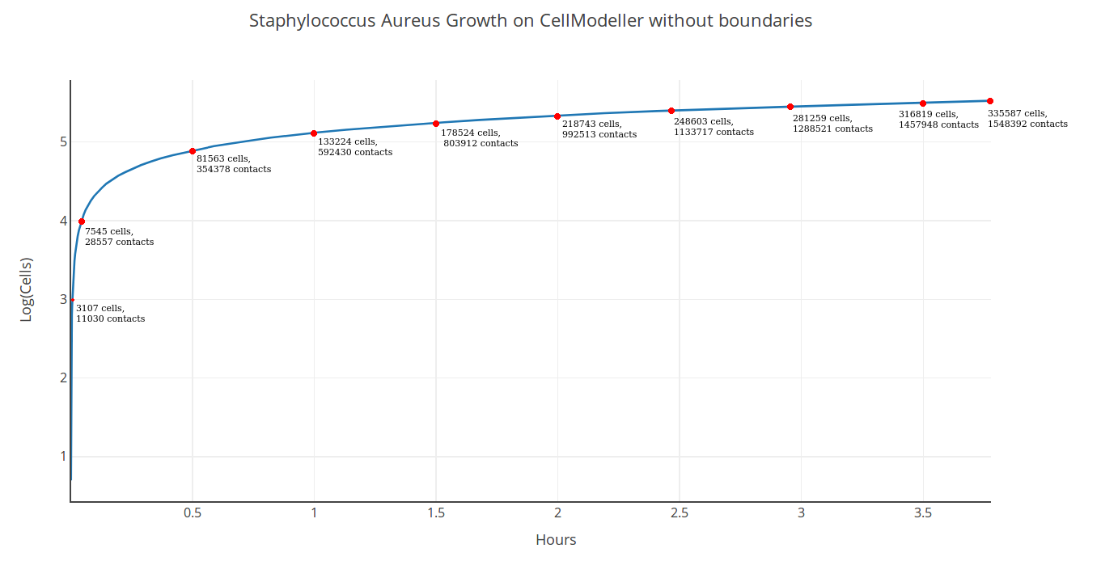

335587 cells with 1548392 contacts were produced in 3.77 hours.

Experiment 2. With Boundaries:

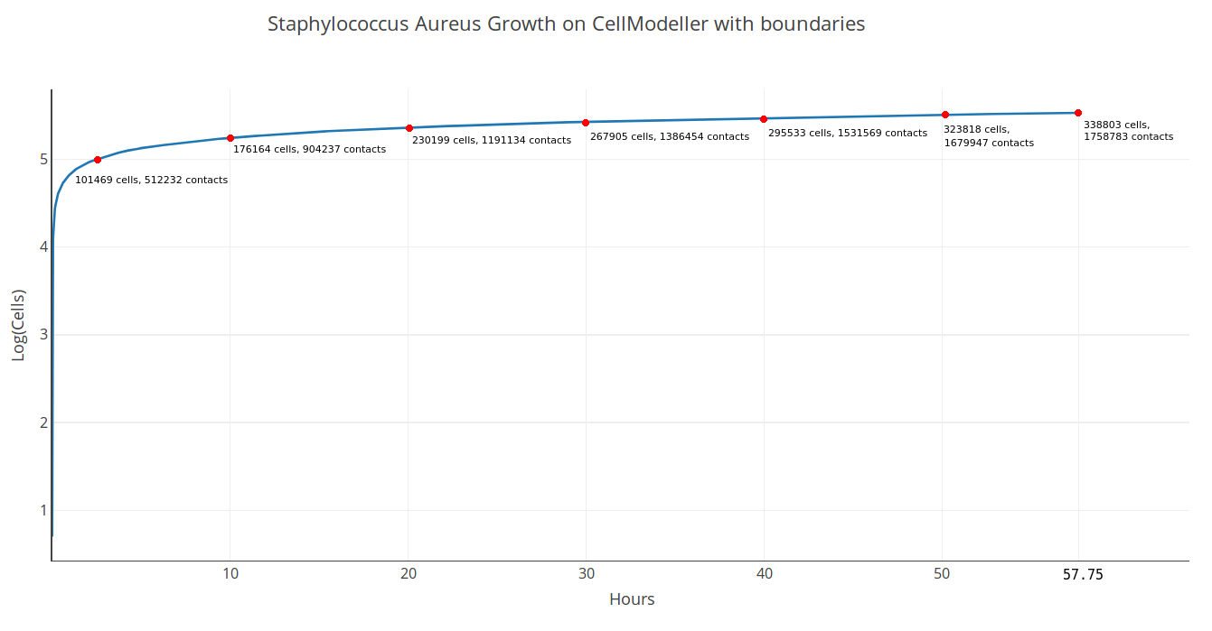

Comparatively, 335493 cells with 1741518 contacts were produced in 56.17 hours. The simulation ended with 338803 cells, 1758783 contacts in 57.75 hours.

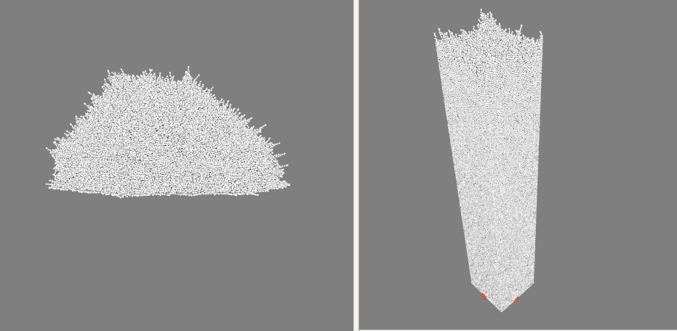

Figure: Side by side comparisons of experiment 1 vs experiment 2 on CellModeller

Questions that need to be answered:

1. Looking at the above to cases, which of the two is representative of biofilm growth and which one is growth of a multicellular organism?
2. How is growth time related to the establishment of the 2 growth models?

Earlier experiment in 2016:

330991 cells with 2177129 contacts were produced in 24.66 hours with boundaries on Siddhant's GTX 980 Ti GPU that has the same architecture (Maxwell) as that of current Titan X GPU. So computation speed wise both are on similar benchmarks. But to reconfirm it, we can repeat the E.Coli experiment again with Titan X if required.